
Turn Real-World Challenges into Reliable Results!

PBL Assay Science – your resource for Interferon and Cytokine Research

For 35 years, PBL has been the premier resource for interferon and cytokine research tools, delivering high-quality immunoassays that work in real-world conditions, recombinant proteins that have been the market standard for 35 years, and antibodies used by thousands of scientists worldwide

Measuring cytokines with ELISA can be challenging in real-world conditions—where analyte levels are often extremely low, similar proteins risk cross-reactivity, and complex matrices like serum or plasma interfere with accuracy. PBL Assay Science’s ELISA kits are designed to overcome these obstacles, delivering precise and reproducible results for your most critical research applications.
- High-Sensitivity enables low-abundance cytokines detection for better biological insights
- Exceptional Specificity for Endogenous Targets eliminate false data for reliable results
- Superior Matrix-Tolerant Performance ensure relevant results from real-world healthy and diseased samples

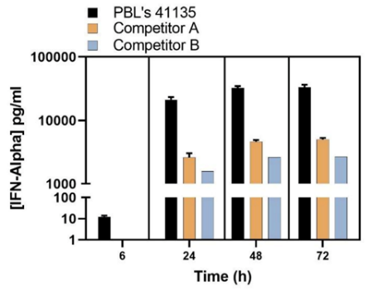 | 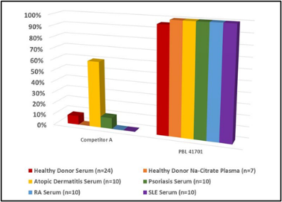
High sensitivity IFN-Alpha All-Subtype detection revealed early IFN-alpha expression point and total IFN-alpha concentrations that other kits missed | Real-world disease patient serum testing for endogenous IL-22 shows near-100% detectability compared to other kits that failed to detect IL-22 in disease serum | Levels of IFN-Beta quantified in normal (healthy) human sera (NHS) and Multiple Sclerosis (MS) patient sera with and without IFN treatment

Type I Interferon research often faces practical challenges in the lab, including variability in protein activity between lots, inaccurate dosing from mass-based measurements, and cross-reactivity among subtypes. PBL Assay Science addresses these issues by providing lot-tested proteins in activity units and validated antibodies for dependable results.
- Lot-Specific Bioactivity Testing ensures consistent performance across experiments by reducing variability, giving researchers confidence in reproducible results
- Functional proteins are provided in activity units rather than mass, allowing researchers to dose based on biological potency instead than weight—critical for accurate functional studies
- Highly Specific Antibodies designed for IFN research that allow IFN-alpha all-subtype neutralization, Type I IFN signal knockdown.

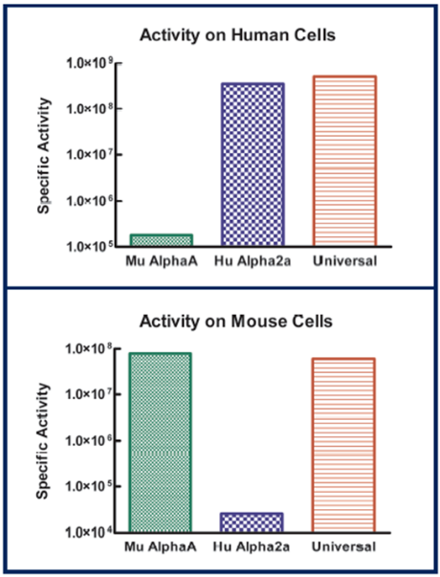 | 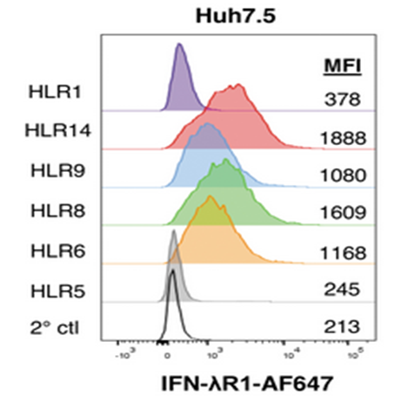 | 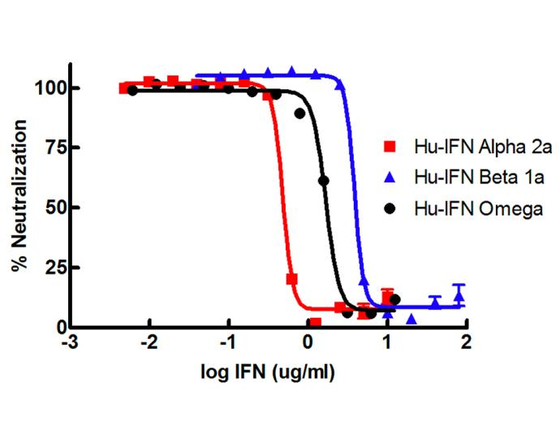
Lot-to-lot bioactivity testing of PBL’s Universal Type I IFN shows cross-species applicability. | Collaborated with IFN researchers to develop fit-for-purpose Anti-human IFNLR1 antibody for Flow Cytometry (de Weerd NA, et al. JICR, 43(9):403, 2023 | Designed to address real-world challenges such as comprehensive human Type I IFNs neutralization

With PBL Assay Science, you can trust your data and accelerate discoveries in immunology, inflammation, and translational research.

Company Contact Information

